Binary Tomography Reconstruction
SSIP 2009
Bartosz Zielniski – Jagellionan University, Cracow, Poland, 2nd year Ph.D.
Bogdan Petrovan – Technical University of Cluj-Napoca, Romania, B.Sc.
Leszek Nowak – Jagellionan University, Cracow, Poland, 1st year Ph.D.
Mihaly Gara – University of Szeged, Hungary, 1st year Ph.D.
Tomislav Devcic – University of Zagreb, Croatia, 1st year Ph.D.

Introduction
The aim of tomography is to get image of object sections. This method is mostly used in medicine, but also in other fields like archeology, biology, geophysics, materials science, industrial inspection, etc.
In medical tomography the section images are obtained by moving an X-Ray beam around the object (patient) and record the projection on a film positioned diametrically opposed to the X-Ray beam.
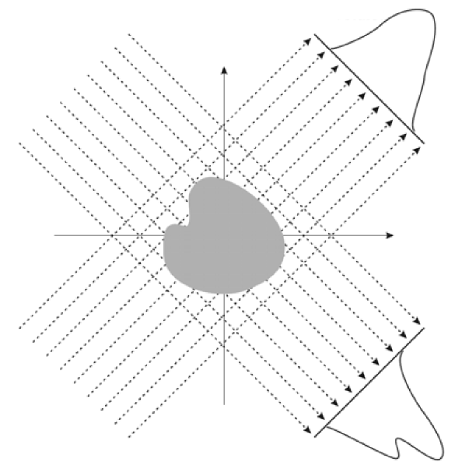
Modern tomography techniques base on collecting projection images from multiple angles and feed them to a tomography reconstruction software algorithm to obtain the section image (see fig. XX). Different types of signal acquisition can be used, not only X-Rays, but the computer algorithms are very similar.
The object, from the mathematically point of view, corresponds to an attenuation function, for which some integrals or sums over a subset are known. Thus two types of tomography reconstruction are posed: continuous tomography and discrete tomography. The continuous tomography assumes that both the domain and the range of the function (object) are continuous. On the other hand, in discrete tomography, the domain of the function could be either continuous or discrete, but the range of the function is a finite set of real numbers.
Usually, in discrete tomography only a few projections are used, thus the algorithms developed for continuous tomography fail in this case. This method is used because the object needed to be reconstructed has fewer levels of intensity and the number of projections could be reduced.
Here is a list of common algorithms used in discrete tomography:
- simulated annealing
- linear relaxation
- branch and bound
- SPG based method
- maximum flow problem
- neural networks
- convex–concave regularization
- evolutionary algorithms
- Kaczmarz method for Algebraic Reconstruction Technique (ART)
Binary tomography is one special case of discrete tomography, where the function (object) can take only 2 values: 0 or 1.
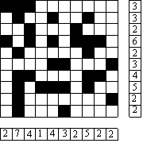
So, practically, the aim of binary tomography is to reconstruct a binary image, where the object is represented in white and the background in black, using projections of the image from few different angles.

Problem description
The problem of reconstruction when using a small number of projections is that there are a large number of solutions, which need somehow to be diminished based on the domain and/or type of the object. Thus a priori information is used, such as convexity, connectedness, roundness, etc.
For obtaining the projections under different angles, we have used the following matrix equation:
$A_{α}⋅X=b_{α}$, where
A – projection matrix (see fig. XX),
X – vector form of the binary image;
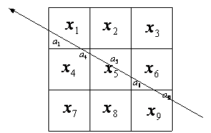
b – the projection of the image;
Also on each projection there is noise added, so we have as program input:
$$b_{α}^{'}=b_{α}+\bar{n}$$

Evolutionary Algorithm for 2D objects
For the implementation of this algorithm we have supposed that the original image is composed of a ring centered on the image with some disjoint disks inside of it. The objects were represented by list of triplets:$(x_{1},y_{1},r_{1}),\text{.}\text{.}\text{.},(x_{N},y_{N},r_{N})$, where $x_{i},y_{i}$represents the center of the disk and $r_{i}$represents the radius of the disk. As an exception, the first and second triplets represent the outer ring.
We used four projections and tried to minimize the target function:
$$f(X)=A_{n}⋅X−b_{n}$$
During the minimization of this function, we used evolutionary algorithm. For this algorithm there is an initial population (represented by a set of coordinates) and for each iteration the population grows using different operators, after which only the “fittest” instances are kept.
The initial population is randomly generated, growing this population using two operators: mutation and crossover. We have used 1000 instances for the initial population.
The mutation operator has only one parent (source instance) and it generates one offspring, the difference between the parent and the offspring could be the number of disks or the size or the coordinates of one randomly chosen disk.
The crossover operator mixes the features (coordinates) from the two parents and generates two offspring.
For these operations we have imposed a constraint that is the resulting offspring must have only disjoint disks.
The “fitness” of an instance is measured by the error (difference) between its projections and the desired projection. Based on the fitness of instances we select only the most 1000 fittest ones for the following generation (iteration). For more details see [1]. Image representation and projection generator are used from DIRECT system [4].

Original | Noiseless |  |  |  | 10% uniform noise |  |  |  | 25% uniform noise
 | Reconstructed |  |  | Error | Reconstructed |  |  | Error | Reconstructed |  |  | Error
 |  |  |  |  |  |  |  |  |  |  | 
 |  |  |  |  |  |  |  |  |  |  | 
 |  |  |  |  |  |  |  |  |  |  | 
 |  |  |  |  |  |  |  |  |  |  | 
 |  |  |  |  |  |  |  |  |  |  | 
 |  |  |  |  |  |  |  |  |  |  | 
 |  |  |  |  |  |  |  |  |  |  | 
 |  |  |  |  |  |  |  |  |  |  | 
 |  |  |  |  |  |  |  |  |  |  | 
 |  |  |  |  |  |  |  |  |  |  | 

Evolutionary Algorithm for 3D object
The algorithm is the same that the one in 2D case, but there is no outer ring and the objects (that are spheres now) can overlap and also partially can get out of the image boundaries.
For 3D reconstruction we have used three projections for each Cartesian plane.

Original image | Reconstructed image
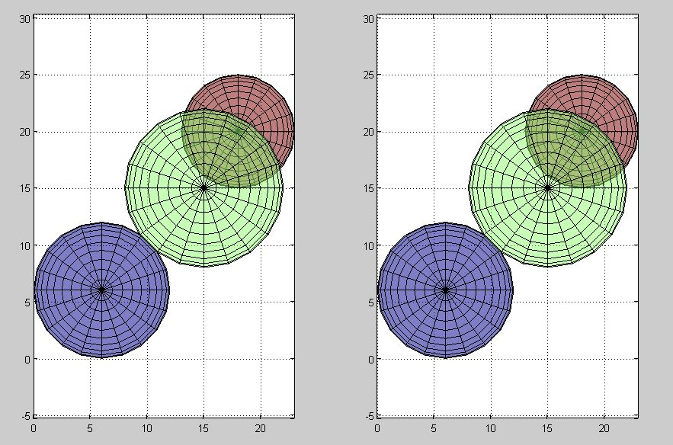
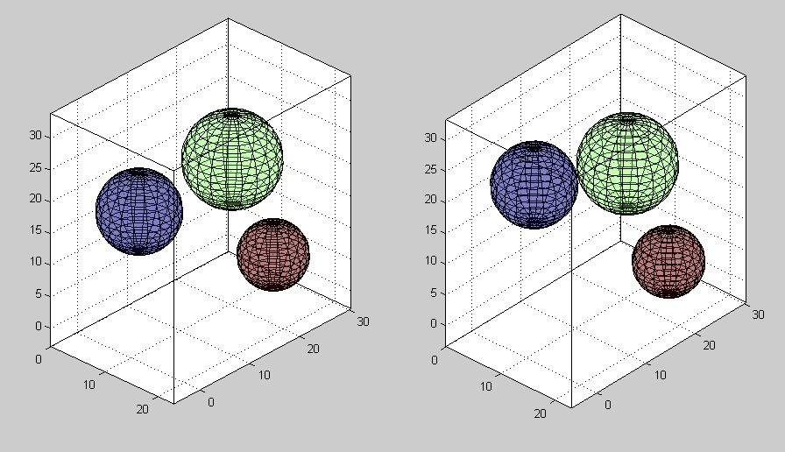

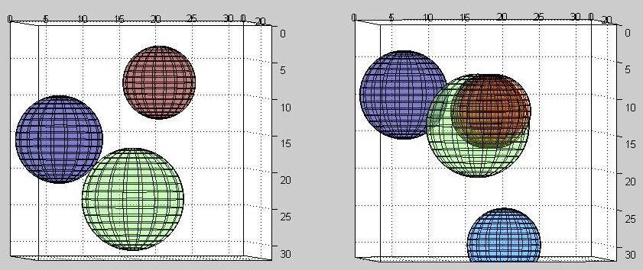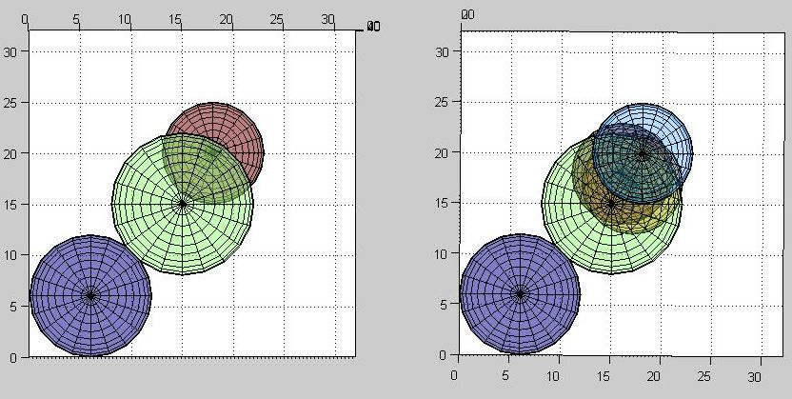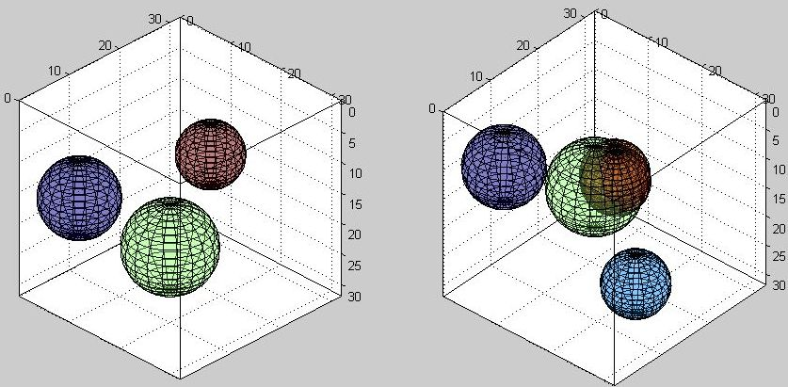
Simplest algorithm
The main idea is to find first possible pixel from two projections (horizontal and vertical) and put it on the result image; then re-iterate the process until there is no more possible ways to put a pixel on the result image.
This method uses only two projections, making it very fast, but it has a lot of errors, like it is shown in the results.
Comparing with the previous method (evolutionary algorithm), this method doesn’t take a priori information, like the shape of the objects in the image.
This method could be slightly improved by using multiple projections, but one should not expect great results.
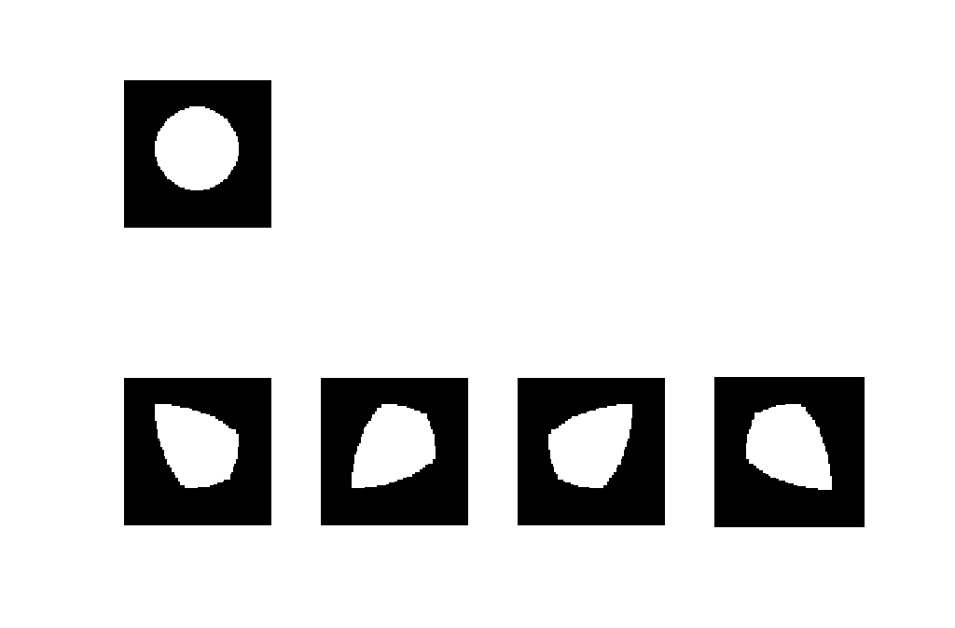
Figure: Original image (the circle) and the reconstructions
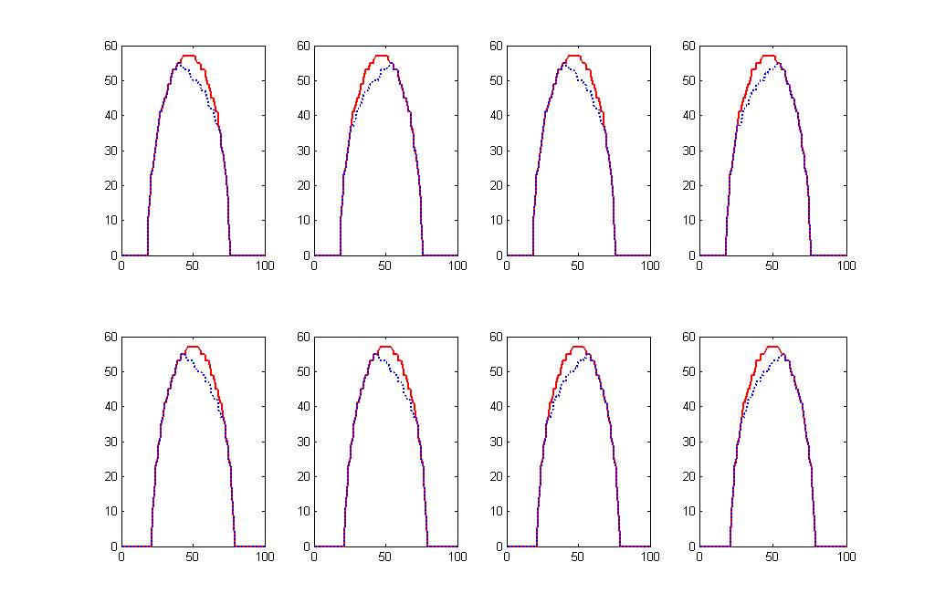
Figure: Original and resulting projections, the top ones are horizontal projections and bottom ones vertical projections; in red is the original (desired) projection and in blue is the result we got.
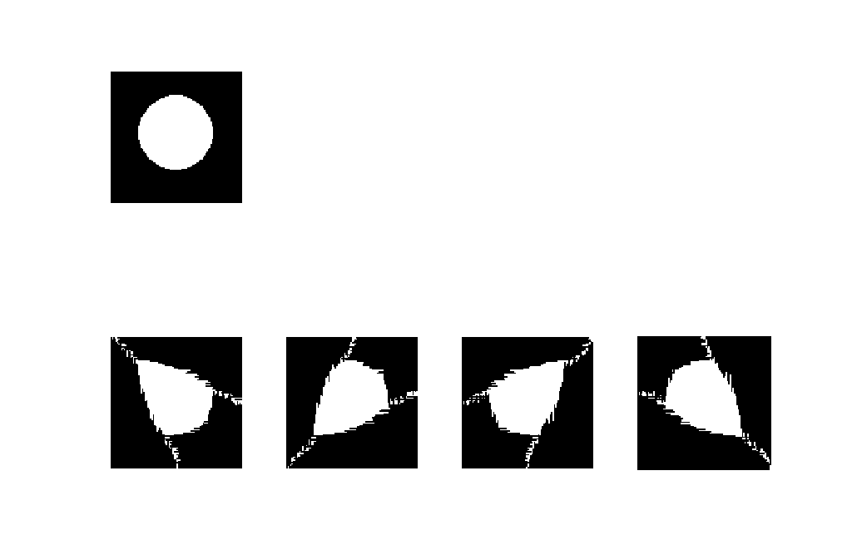
Figure: Same circle image, but adding 5% noise to the projections;
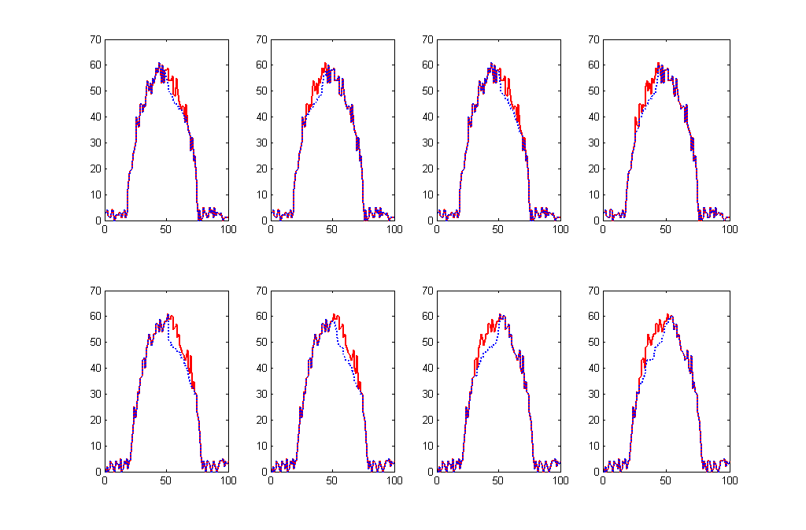
Figure: The projections of the results in the case of noise

Star section algorithm
This algorithm uses multiple projections of the image and tries to find the maximums of each projection and obtain a point of image. Next it starts with this pixel going in different directions, checking if there could be other object pixels, until there couldn’t be more object pixels. Next will re-iterate by finding the maximums of the projections again, choosing a new object pixel, and so on. The algorithm stops if there are no changes between two iterations.
Following there are presented the results of using this algorithm, in the upper left image is the original object, in the lower left image is the reconstructed object, in the upper and lower right parts the projections are presented, in red the original projections and in blue the resulting projections.
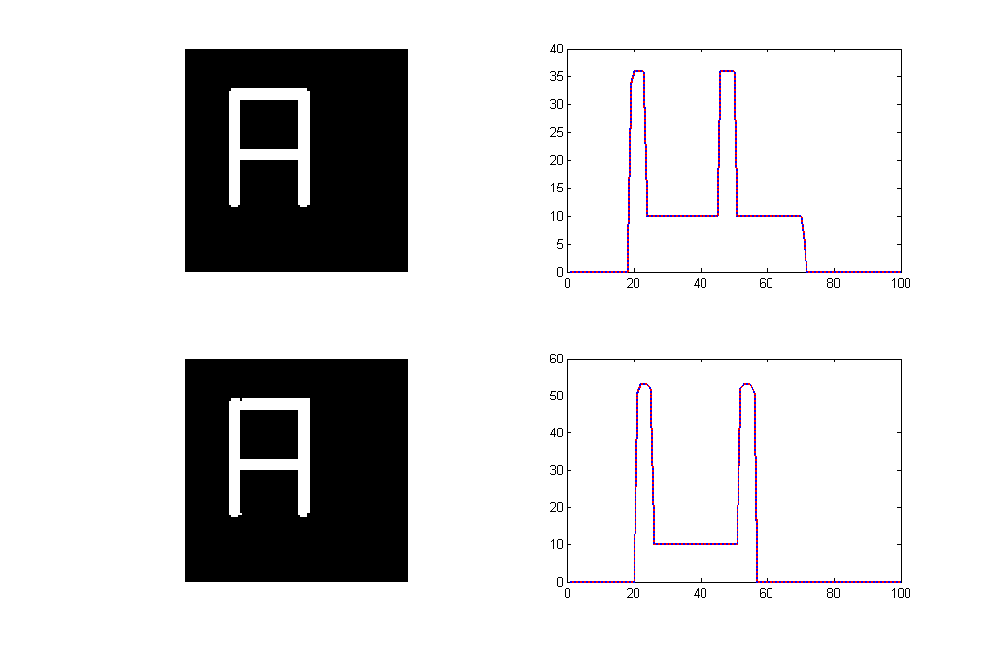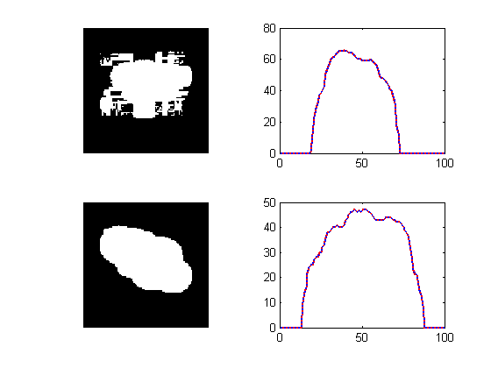
Figure: In the left part the object is the “A” letter and in the right part the object is a blob
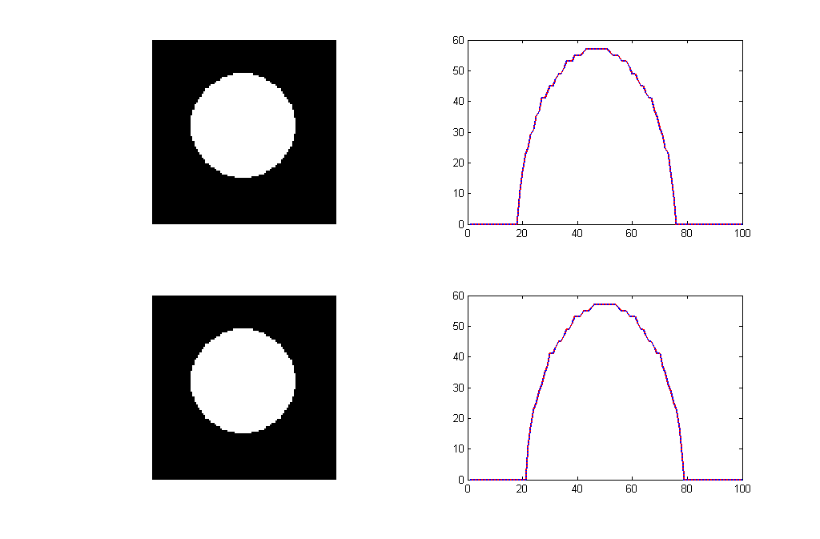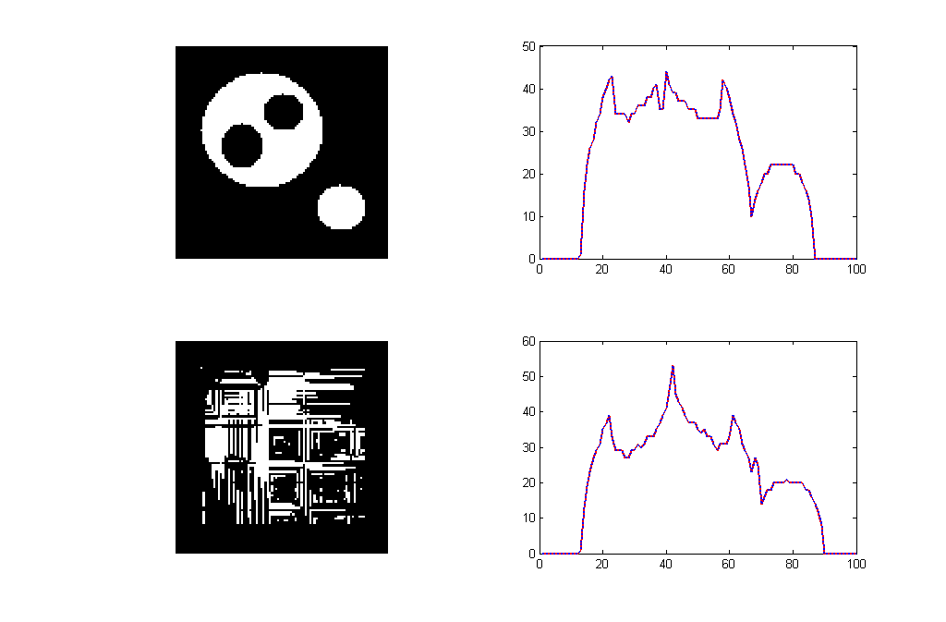
Figure: In the left part the object is a disk and in the right part there are multiple objects, one of them has holes
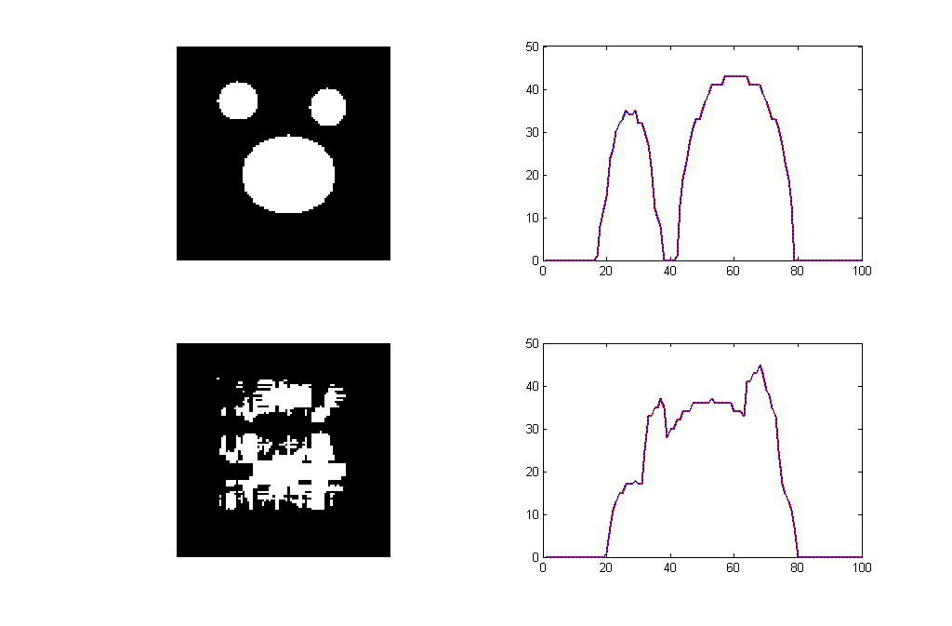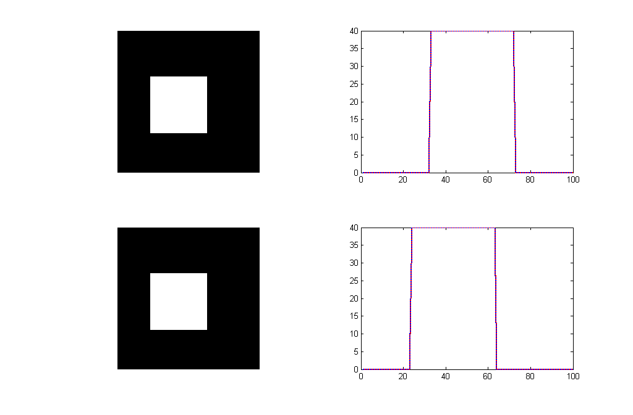
Figure: In the left part there are multiple elliptical objects and in the right part the object is a filled square
Next are presented the results when adding 5% white noise.
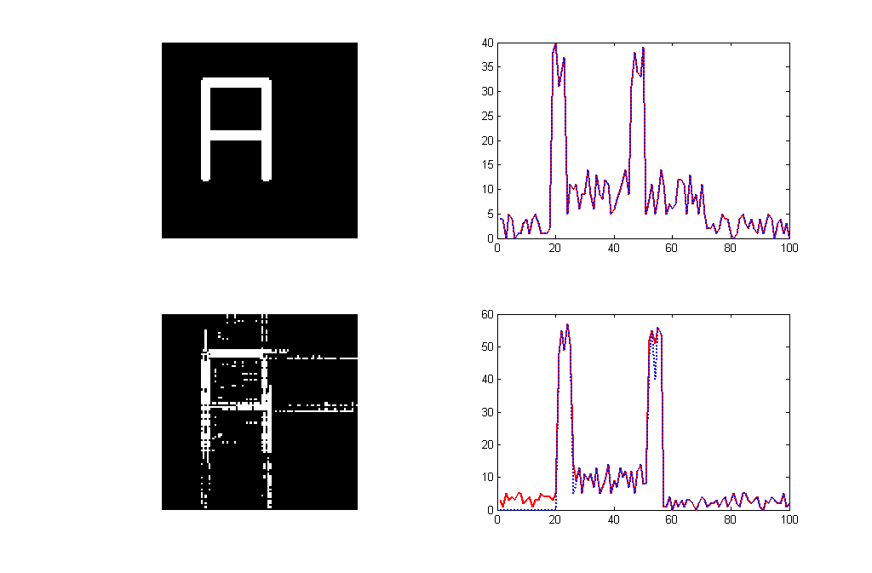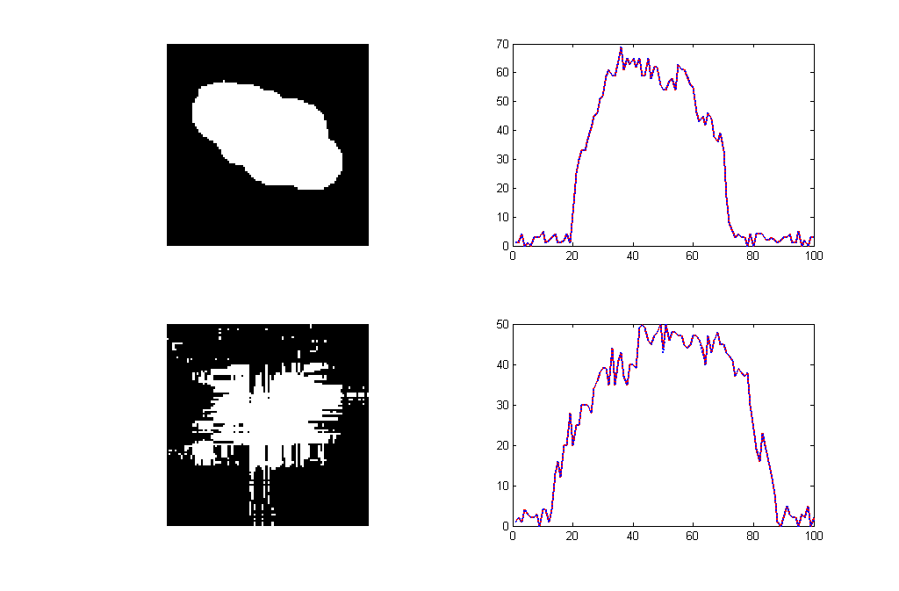
Figure: In the left part the object is the letter “A” and in the right part the object is a blob
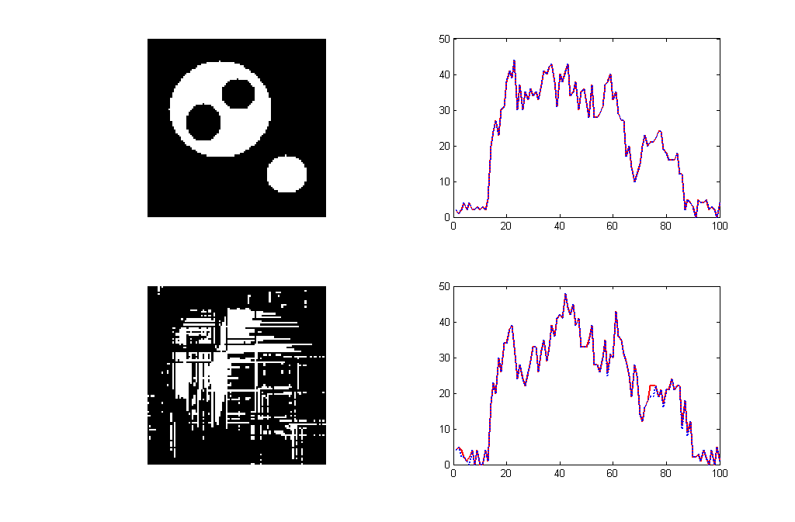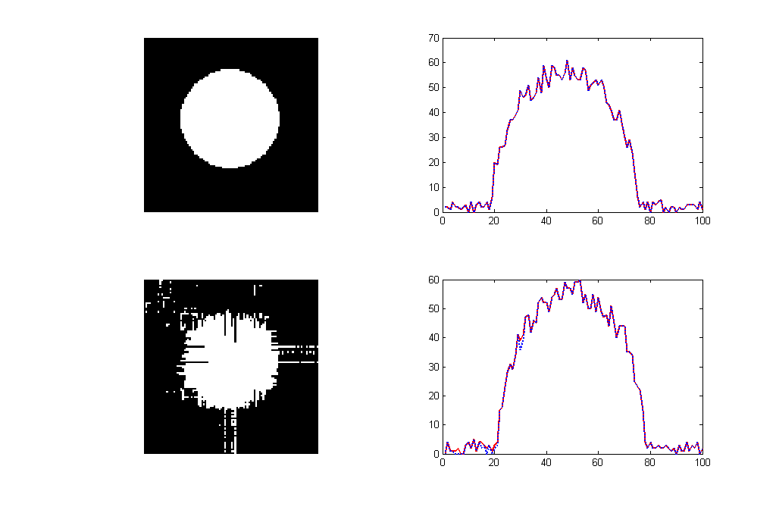
Figure: In the left part there are multiple elliptical objects, one of them having 2 holes and in the right part the object is a circle
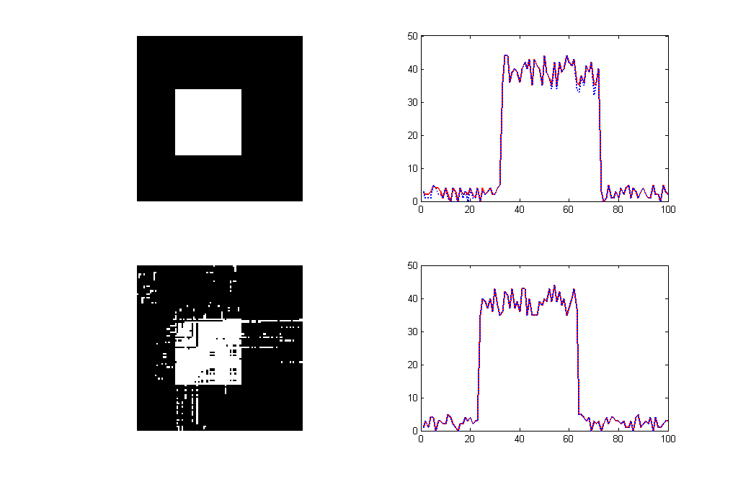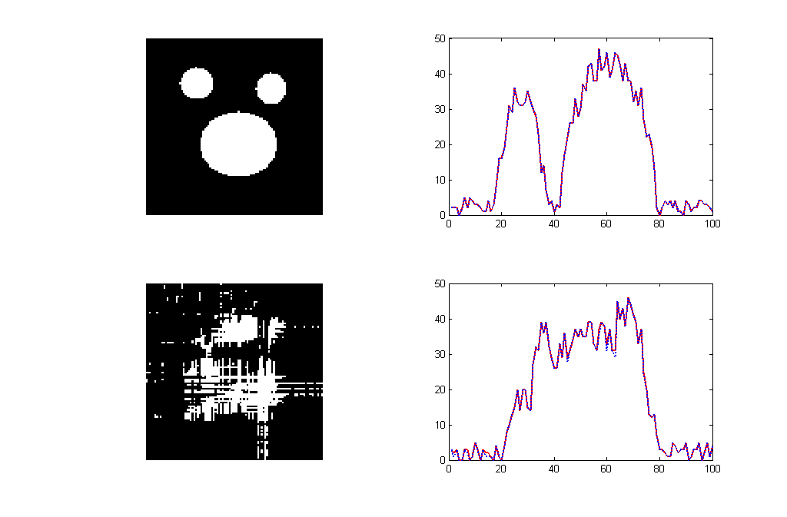
Figure: In the left part the object is a square and in the right part there are multiple elliptical objects

Next are presented the results for using four projections of the image at 0, 45, 90, 135 degrees. In the left part are presented the reconstruction results for the case of no noise and in the right part are presented the results when having 5% noise.

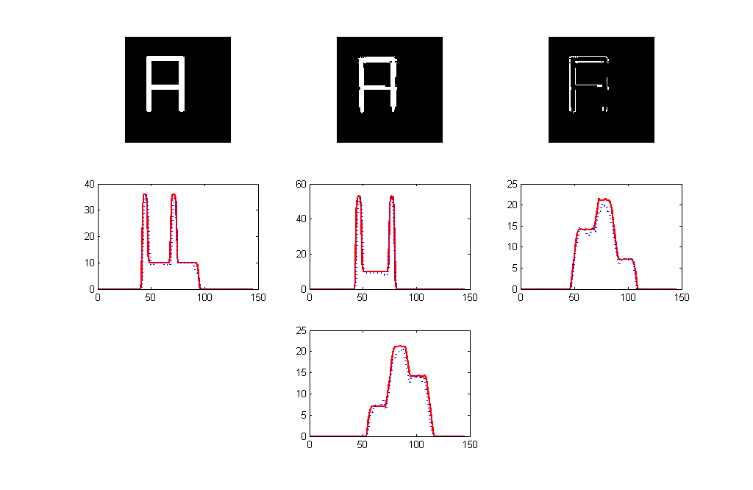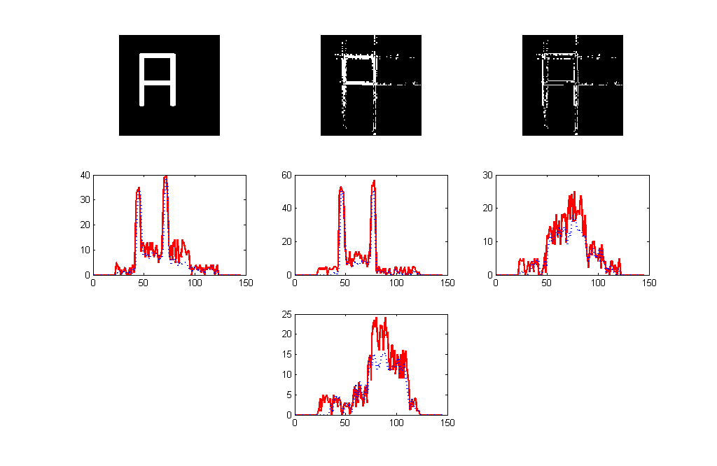
Figure: Object is the “A” letter
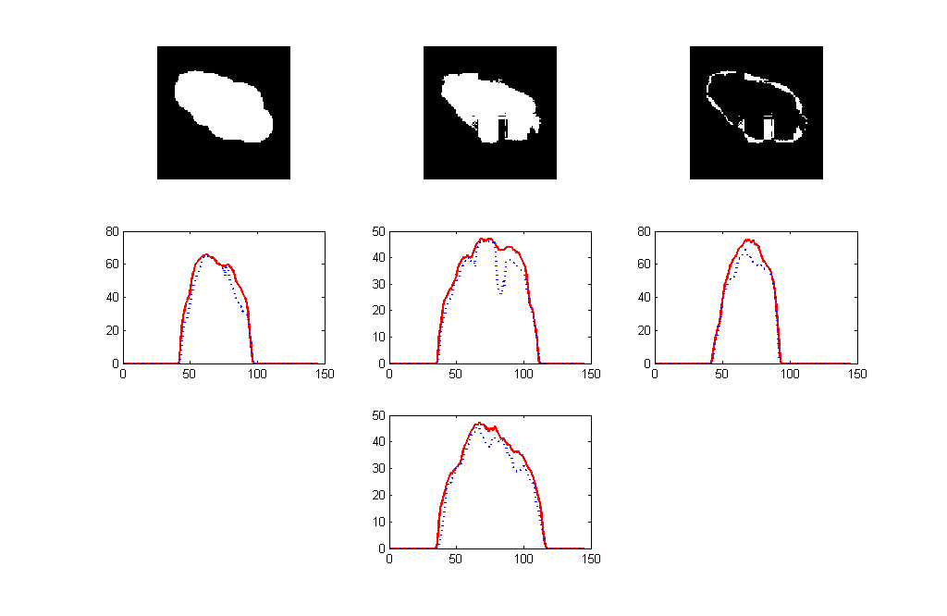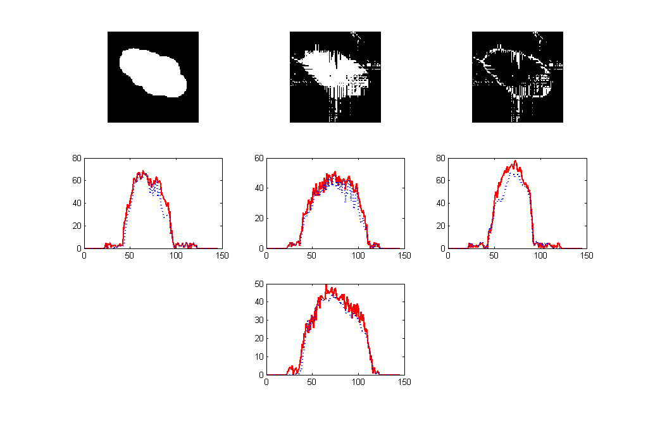
Figure: The object is a blob
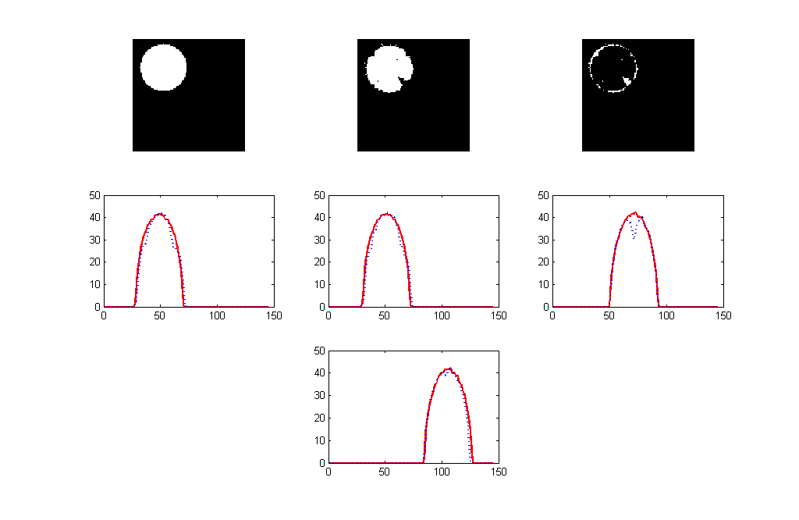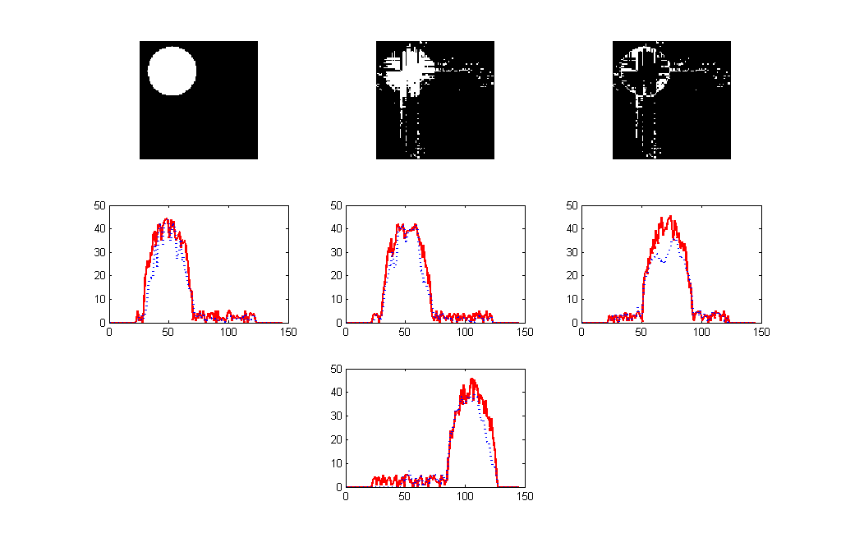

Figure: The object is a circle.
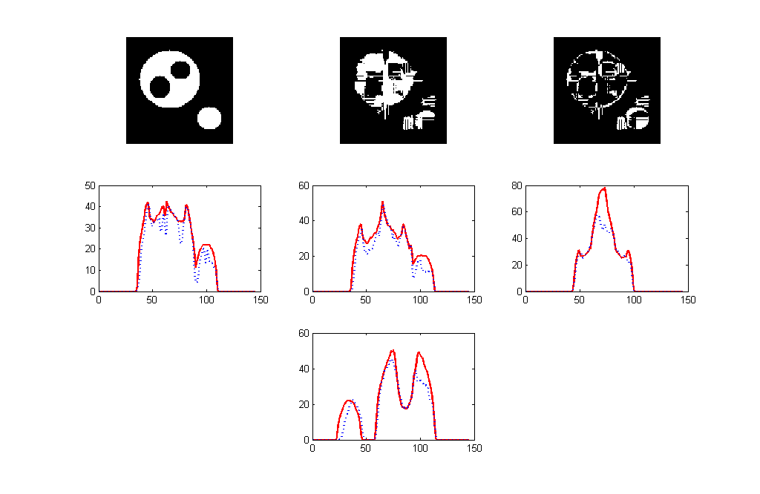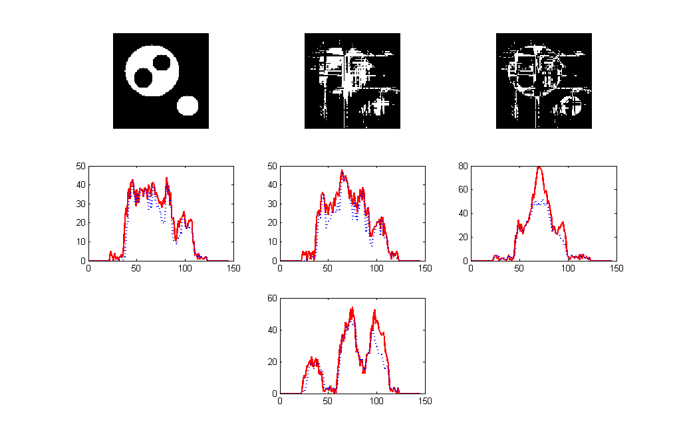
Figure: There are multiple elliptical objects, one of them having also holes in it
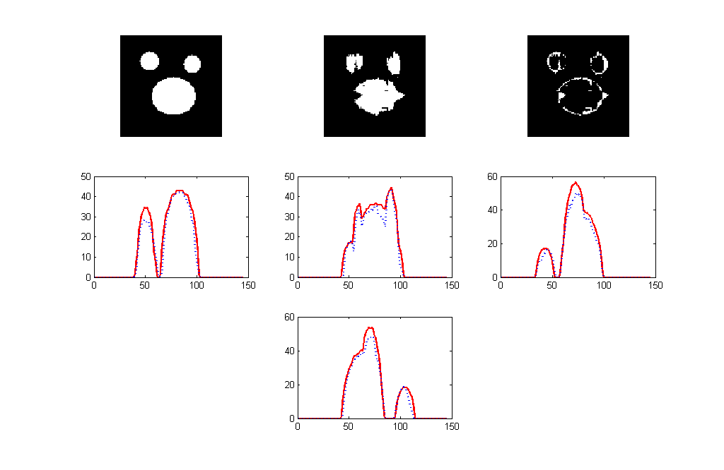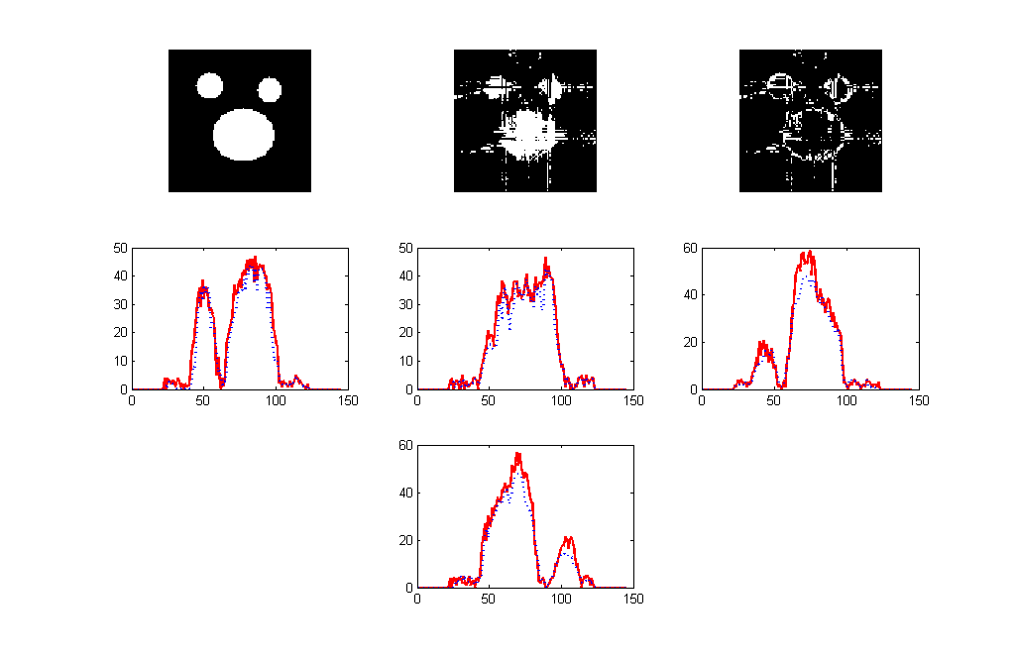
Figure: There are multiple elliptical objects.
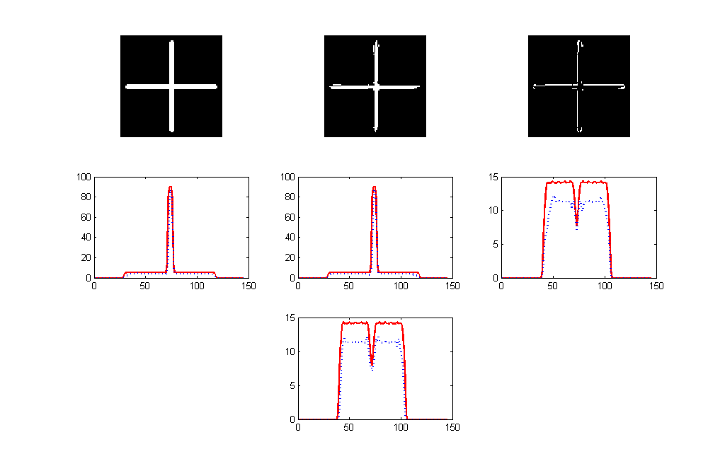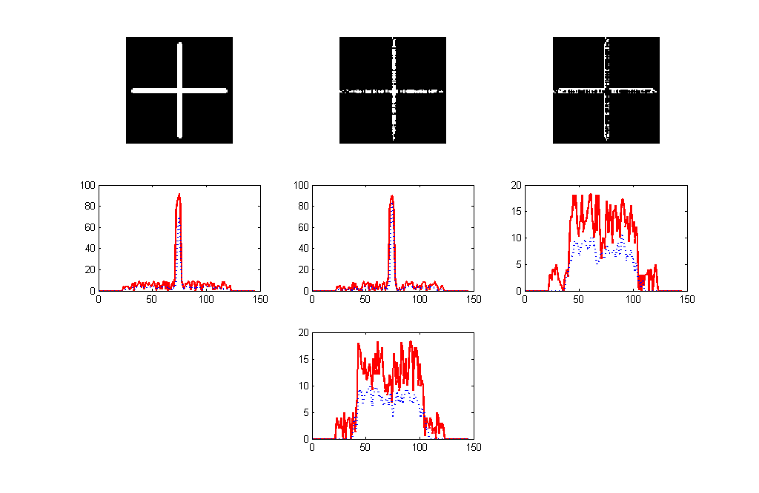
Figure: The object is a cross.
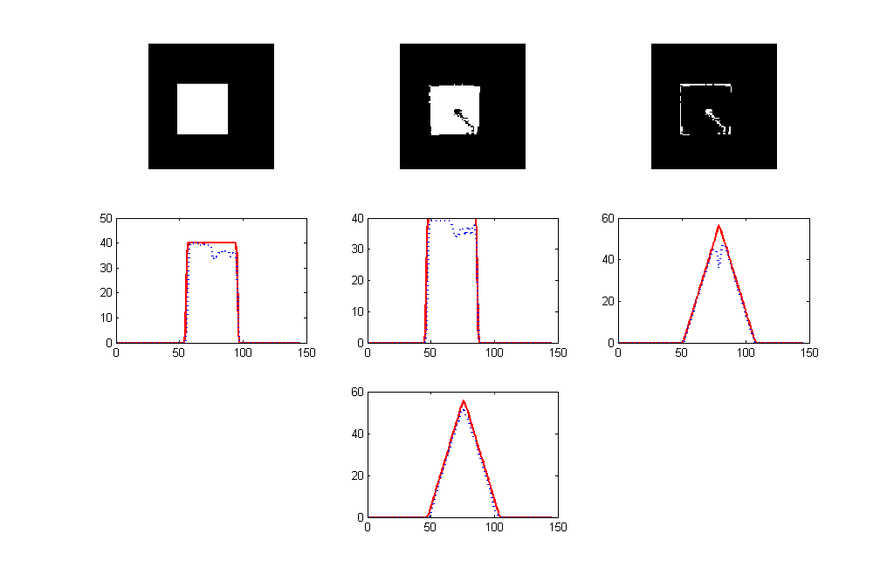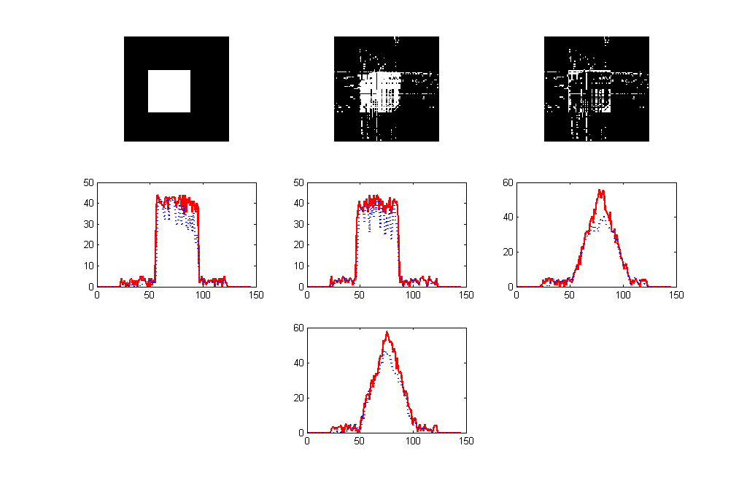
Figure: The object is a filled square

Modified randomized Kaczmarz algorithm

Kaczmarz algorithm is an iterative method for solving linear equation systems, like the one in our problem.
It has been observed in the numerical simulations that the convergence rate of Kaczmarz method can be significantly improved when the algorithm sweeps through the rows of A in a random manner [3], rather than sequentially in the given order. In fact, the improvement in convergence can be quite dramatic. We are using a specific version of this randomized Kaczmarz method, which chooses each row of A with probability proportional to its relevance - more precisely, proportional to the square of its Euclidean norm.

Random Kaczmarz Algorithm: Let Ax=b be a linear system of equations and let $x_{ö}$be arbitrary initial approximation to the solution. For k=0,1,... compute:

$$x_{k+1}=x_{k}+\frac{b_{r(i)}−\left\langle a_{r(i)},x_{k}\right\rangle }{{\left\|a_{r(i)}\right\|}_{2}^{2}}a_{r(i)}$$

where r(i) is chosen from the set {1,2,...,m} at random, with probability proportional to ${\left\|a_{r(i)}\right\|}_{2}^{2}$.

This method is usually used in discrete tomography. Although with some modifications [2] it could be used in binary tomography.
This algorithm was modified for preventing a pixel’s value to exceed the limits ([0,1]), but in the same time to preserve the increment energy.
Following three results of this method are presented. For obtaining these images 500 iterations were done and were used 20 projection planes.

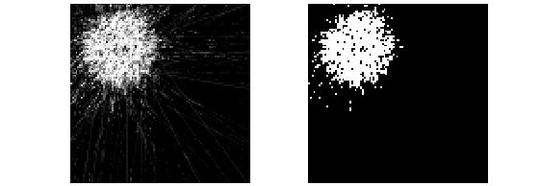

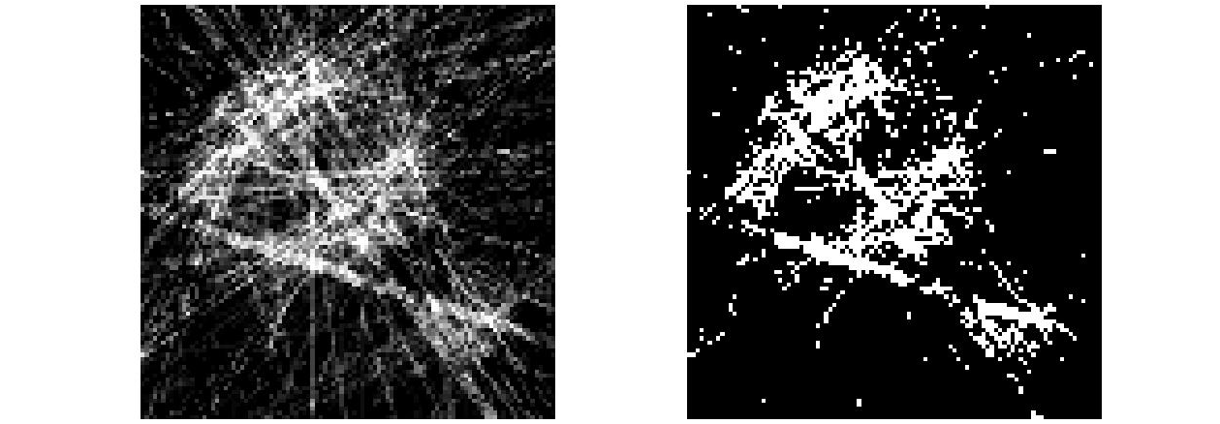

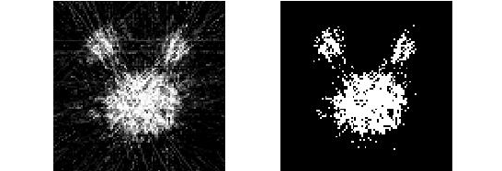

From these images it can be seen that the results compared to other methods are worse. This can be explained by the fact that this method is usually used for discrete images. For getting a better result in binary images it is needed to be found a better heuristic solution for redistributing incremental energy which is added in every iteration step to a pixel’s value.

References:
[1] Balázs, P., Gara, M.: An Evolutionary Approach for Object-Based Image Reconstruction Using Learnt Priors. Lecture Notes in Comput. Sci., 5575, 2009.
[2] Batenburg, K. J., Sijbers, J.: DART: A Fast Hheuristic Algebraic Reconstruction Algorithm. Proc. of ICIP 2007 (IEEE Conference on Image Processing), IV 133-136.
[3] Strohmer, T. and Vershynin, R.: A randomized Kaczmarz algorithm with exponential convergence
[4] www.inf.u-szeged.hu/~direct

