Skeletonization and its applications
Kálmán Palágyi
Dept. Image Processing and Computer Graphics, University of Szeged
palagyi@inf.u-szeged.hu

Introduction

Shape representation
The generic model of a modular machine vision system is illustrated in Fig. 1. It contains seven sub-systems. One of them is the feature extraction. After a digital image has been segmented into meaningful regions or objects, it is usually of interest to represent them. Recognition of segmented objects is an important step on the way to understanding image data, and requires an exact description in a form suitable for a classifier.

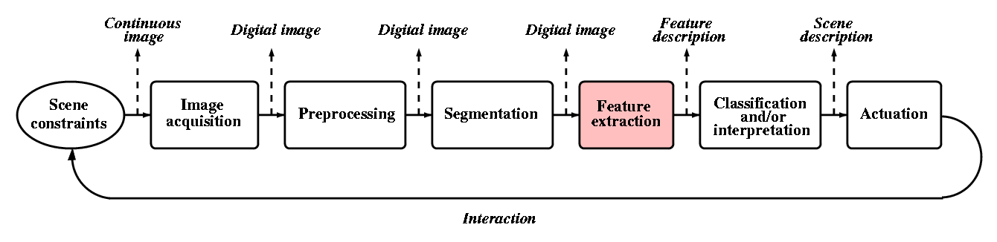
Fig. 1.: The generic model of a modular machine vision system. The feature extraction step converts a segmented image into feature/shape descriptors.

Many of the features of interest are concerned with the shape of the objects. The shape is a fundamental concept in computer vision. It can be regarded as the basis for high-level image processing stages concentrating on scene analysis and interpretation. Basically, there are two major approaches for shape representation. The first method describes the boundary that surrounds an object; the second one gives a representation of the region that is occupied by the object to be analyzed.

Boundary-based techniques are widely used but there are some deficiencies which limit their usefulness in practical applications especially in 3D. Therefore, the importance of the region-based shape features shows upward tendency. In this paper, our attention is focused on a region based shape feature called skeleton.

The skeleton
Skeleton was introduced by Blum as a result of the Medial Axis Transform (MAT) or Symmetry Axis Transform (SAT). The MAT determines the closest boundary point(s) for each point is in an object. An inner point belongs to the skeleton if it has at least two closest boundary points (see Fig. 2).
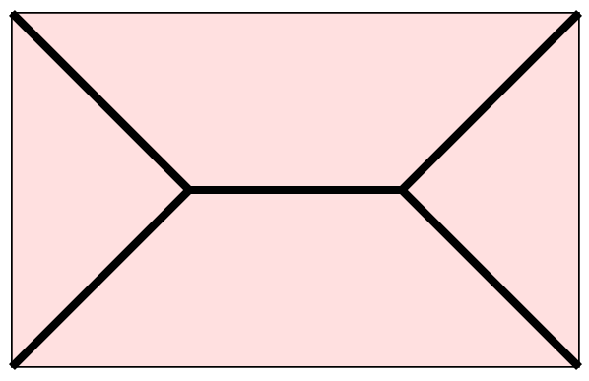
Fig. 2.: A solid rectangle and its skeleton (marked by thick lines).

A very illustrative definition of the skeleton is given by the prairie-fire analogy: the boundary of an object is set on fire and the skeleton is the loci where the fire fronts meet and quench each other.
The third approach provides a formal definition: the skeleton is the locus of the centers of all maximal inscribed hyper-spheres (i.e., discs and balls in 2D and 3D, respectively), see Fig. 3. Note, that an inscribed hyper-sphere is maximal if it is not covered by any other inscribed hyper-sphere.
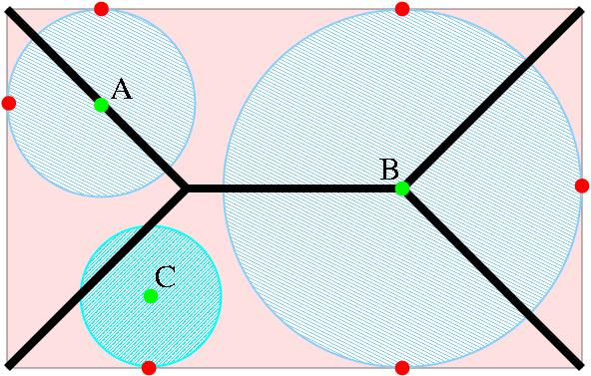
Fig. 3.: A rectangle and its skeleton with some inscribed discs. The discs with centers A and B are maximal ones, therefore, both points A and B belong to the skeleton. Point C is not skeletal, since the corresponding disc is not maximal. Note, that an inscribed disc is maximal if and only if it touches the boundary at least in two points.

Note that these definitions can be naturally extended to any dimension. The continuous skeleton of a solid 3D box is illustrated in Fig. 4.

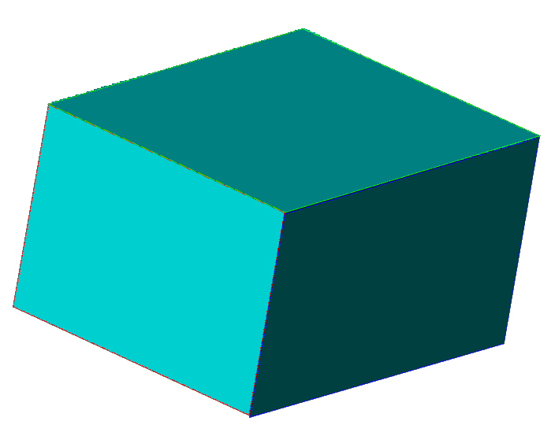 | 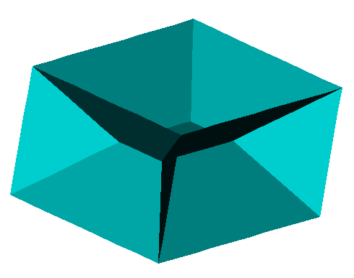
Fig. 4.: A 3D solid box (left) and its skeleton (right). Note, that the skeleton is 3D generally contains surface patches.

Skeletonization
In the last two decades, skeletonization (i.e., skeleton extraction from binary digital images) has been an important research field. There are two major requirements to be complied with. The first one is geometrical. It means that the extracted “skeleton” must be in the middle of the object and invariant under geometrical transformations. The second one is topological requiring that the “skeleton” must be topologically equivalent to the original object.

There are three major discrete skeletonization methods:
- detecting ridges in distance map of the boundary points
- calculating Voronoi diagram generated by the boundary points, and
- iterative layer-by-layer erosion called thinning.

Comparison of skeletonization techniques:
method | geometrical | topological
distance-based | yes | no
Voronoi-based | yes | yes
thinning | no | yes

Distance transformation
Skeletonization based on distance transformation requires the following 3-step process:
- The original (binary) image is converted into feature and non-feature elements. The feature elements belong to the boundary of the object.
- The distance map is generated where each element gives the distance to the closest feature element.
- The ridges (local extremes) are detected as skeletal points.

Fig. 5. shows an example of distance mapping.
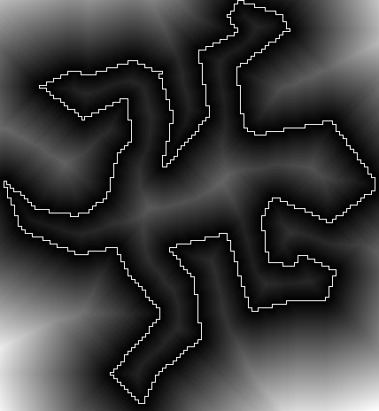
Fig. 5.: A 2D distance map in which the feature points are the boundary points.

The distance map resulted by the distance transformation depends on the chosen distance. The distance transformation can be executed in linear (O(n)) time in arbitrary dimensions, where n is the number of the image elements (e.g., pixels or voxels). This method fulfils the geometrical requirement (if an error-free Euclidean distance map is calculated), but the topological correctness is not guaranteed.

Voronoi diagram
The Voronoi diagram of a discrete set of points (called generating points) is the partition of the given space into cells so that each cell contains exactly one generating point and the locus of all points which are closer to this generating point than to other generating points.
If the density of boundary points (as generating points) goes to infinity then the corresponding Voronoi diagram converges to the skeleton (see Fig. 6).

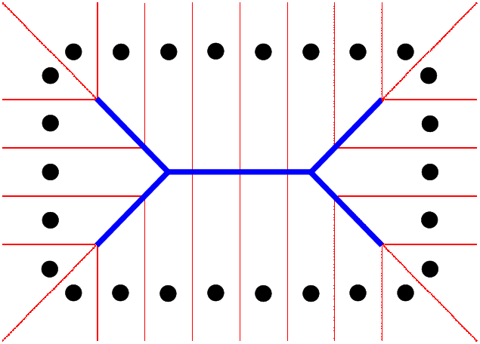

Fig. 6.: A Voronoi diagram (left) and the Voronoi diagram generated sampled boundary of a rectangle (right). The thick Voronoi edges belong to the skeleton.

Both requirements (i.e., the topological and the geometrical ones) can be fulfilled by the skeletonization based on Voronoi diagrams, but it is an expensive process, especially for large and complex objects.

Thinning
Thinning is an iterative object reduction technique for extracting an approximation to the skeleton of discrete objects. It is based on digital simulation of the fire front propagation: border points (i.e., object points that are adjacent to the background) of a binary object that satisfy certain topological and geometric constraints are deleted in iteration steps. The entire process is repeated until only a reasonable approximation to the skeleton is left (see Fig. 7).

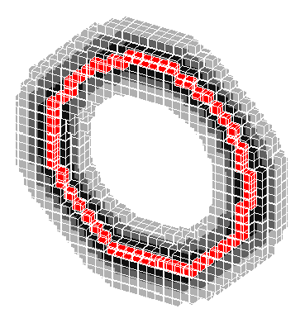 | 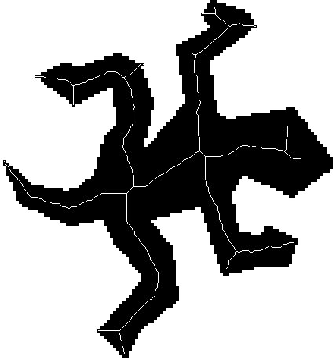

Fig. 7.: The phases of the thinning of a 3D doughnut (left). An elongated 2D object and its skeleton extracted by a thinning algorithm (right).
The topologically oriented thinning pays less attention to the metric properties of the object, therefore, the invariance under rotation (object orientation) and invariance under scaling are not guaranteed. It is possible to combine the distance transform based methods with the thinning process: points representing the centers of maximal inscribed spheres are determined by a distance-based method (as a separate preprocessing step) and those points (anchor points) are to be preserved in the following thinning procedure. In this way, both geometrically and topologically correct skeleton can be extracted.
We prefer thinning, since it:
- preserves topology,
- makes easy implementation possible,
- takes the least computational costs,
- can be executed in parallel.
In addition, we can extract more types of skeleton-like 3D features by applying different end-point criteria: if we preserve surface-end or line-end points, we get surface-skeleton (medial surfaces) or curve-skeleton (medial lines or centerlines). If we deal only with the topological correctness and do not preserve any end-points, we get the topological kernel of an object. The three kinds of “skeletons” are presented in Fig. 8.
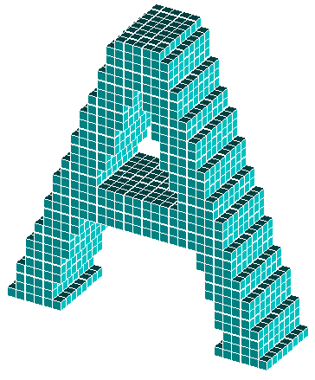 | 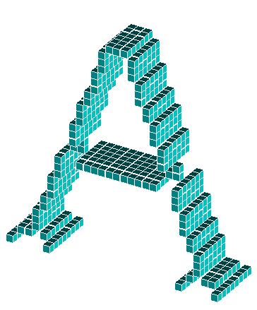 | 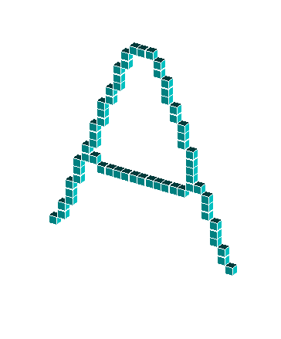 | 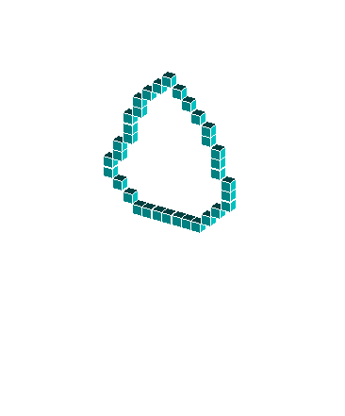
a | b | c | d

Fig. 8.: Types of 3D “skeletons”: original object (a), medial surface (b), centerlines (c), and topological kernel (d).

Some applications
This section presents some practical applications of different classes of binary digital images. Our attention is focused on 3D medical applications, therefore, conventional 2D applications (e.g., preprocessing of raster-to-vector conversion, processing of line images (say printed circuits or road maps), fingerprint or palmprint identification, hand-written text processing, signature verification) are omitted here.

Assessment of laryngotracheal stenosis (LTS)
Many conditions can lead to LTS, most frequent endotracheal intubation, followed by external trauma, or prior airway surgery. Clinical management of these stenosis requires exact information about the number, grade, and the length of the stenosis. The cross-sectional profiles perpendicular to the centerline of the upper respiratory tract (URT) were presented as line charts (see Fig. 9).

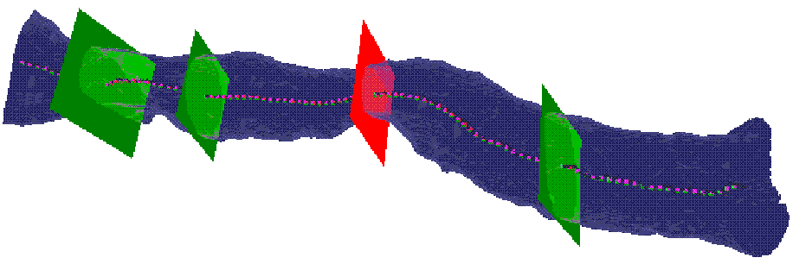
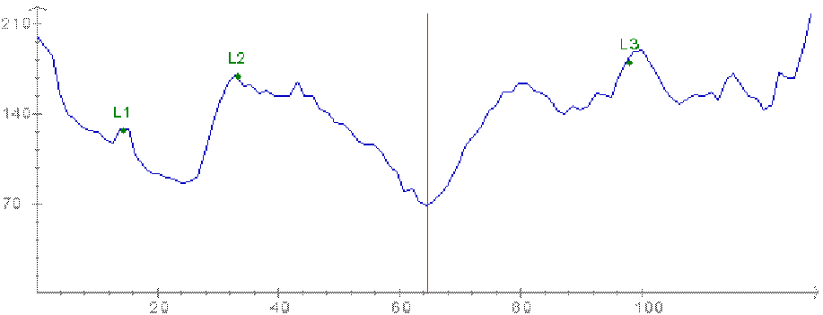

Fig. 9.: The segmented URT, its centerline, its cross--sectional profile at the three landmarks (i.e. vocal cords, caudal border of the cricoid cartilage, and cranial border of the sternum) and at the narrowest position (top) and the corresponding line chart (bottom).

Assessment of infrarenal aortic aneurysms
We used the cross-sectional profile in patients suffering from infra-renal aortic aneurysms (AAA). AAA are abnormal dilatations of the main arterial abdominal vessel due to atherosclerosis. For therapy two main options exist: surgery or endoluminal repair with stentgrafts. For optimal patient management the “true diameter” in 3D has to be known. Figure 10 shows the segmented infrarenal aorta and its centerline. Along the centerline the cross-sectional profile was computed.

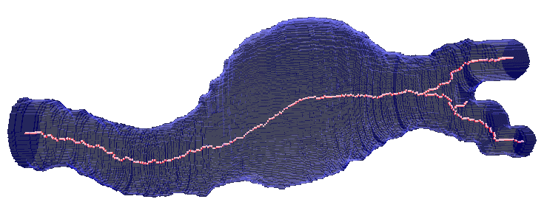

Fig. 10.: The segmented part of the blood vessel and its centerline.

Unravelling the colon
Unravelling the colon is a new method to visualize the entire inner surface of the colon without the need for navigation. This is a minimally invasive technique that can be used for colorectal polyps and cancer detection. In this section we present an algorithm for unravelling the colon which is to digitally straighten and then flatten. Comparing to virtual colonoscopy where polyps may be hidden from view behind the folds, the unravelled colon is more suitable for polyp detection, because the entire inner surface is displayed in one view (see Fig. 11).

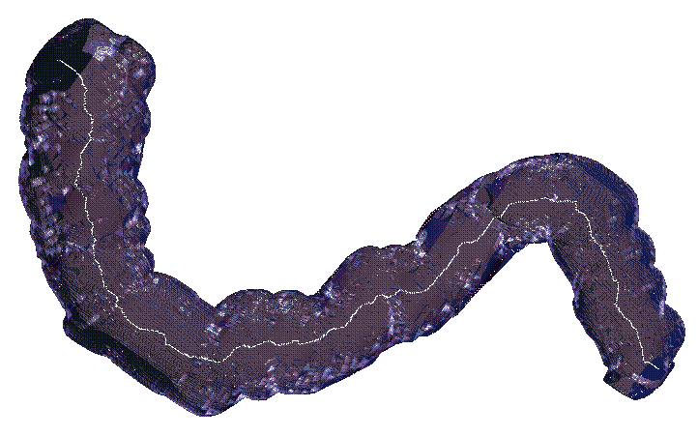 | 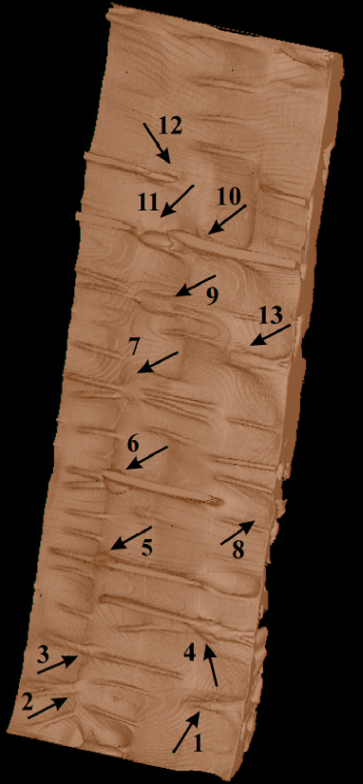

Fig. 11.: The segmented volume of a cadaveric phantom and its central path (left) and the unravelled colon (right). Note that numbers mark the detected polyps.

Analysis of intrathoracic airway trees
A method for quantitative assessment of tree structures is developed allowing evaluation of airway or vascular tree morphology and its associated function. Centerline extraction and branch-point identification provide a basis for tree quantification or tree matching, tree-branch diameter measurement in any orientation, and labeling individual branch segments (see Fig. 12).

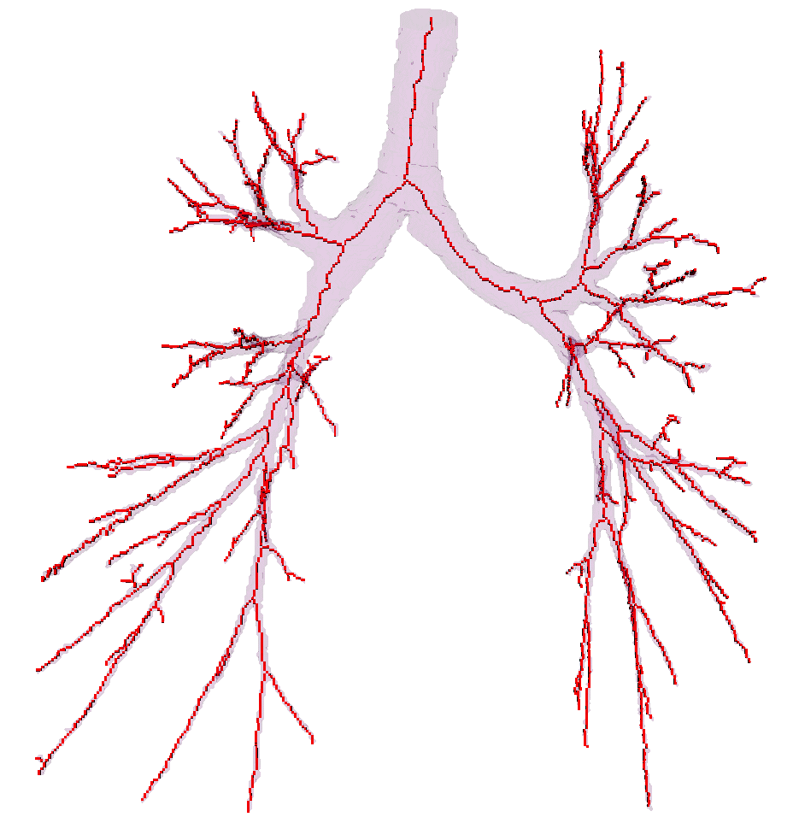 | 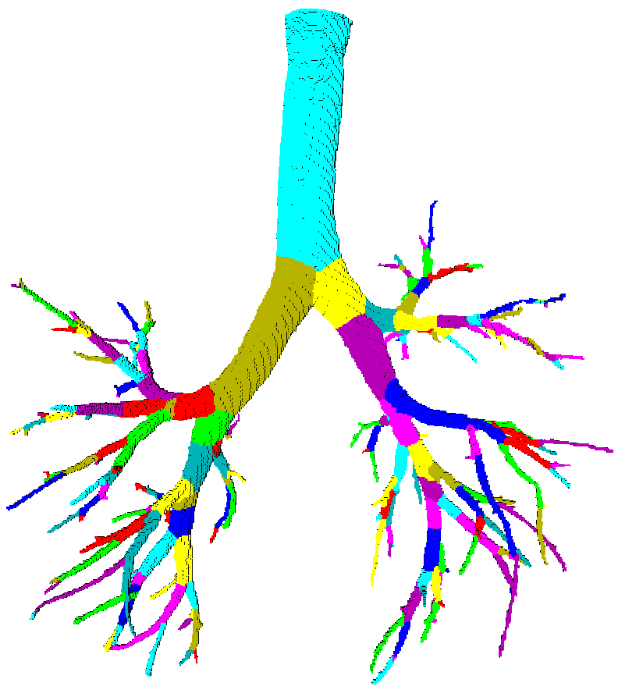

Fig. 12.: A segmented human airway tree and its centerlines (left), a partitioned airway tree in which a branch-specific label is assigned to each voxel (right).
For each branch of the partitioned tree, some measures (quantitative indices) are calculated: branch length, branch volume, branch surface area, and branch diameter.
The unit-wide centerlines contain only three types of points: line-end points, line-points, and branch-points. The identified branch-points provide a basis for tree matching (i.e., determining a correspondence between the branches of two trees) and anatomical labeling (see Figs. 13 and 14).

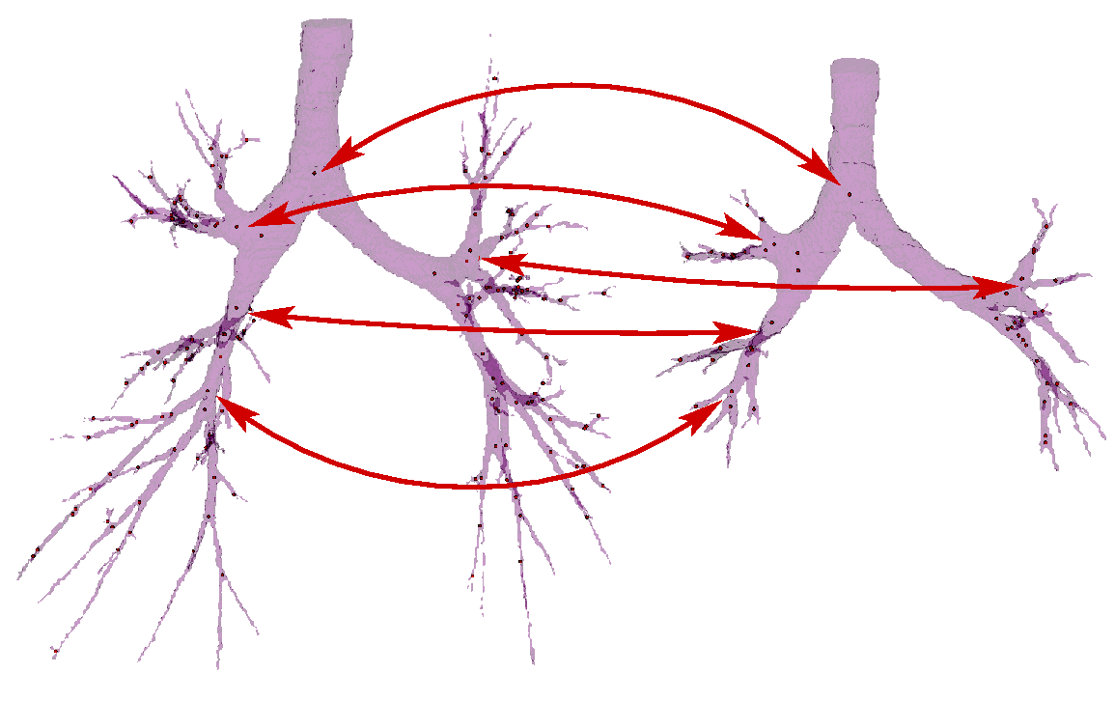Fig. 13.: Tree matching based on the identified branch-points.

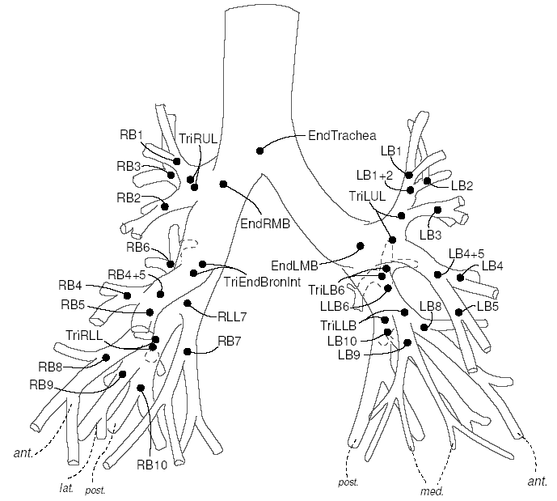 | 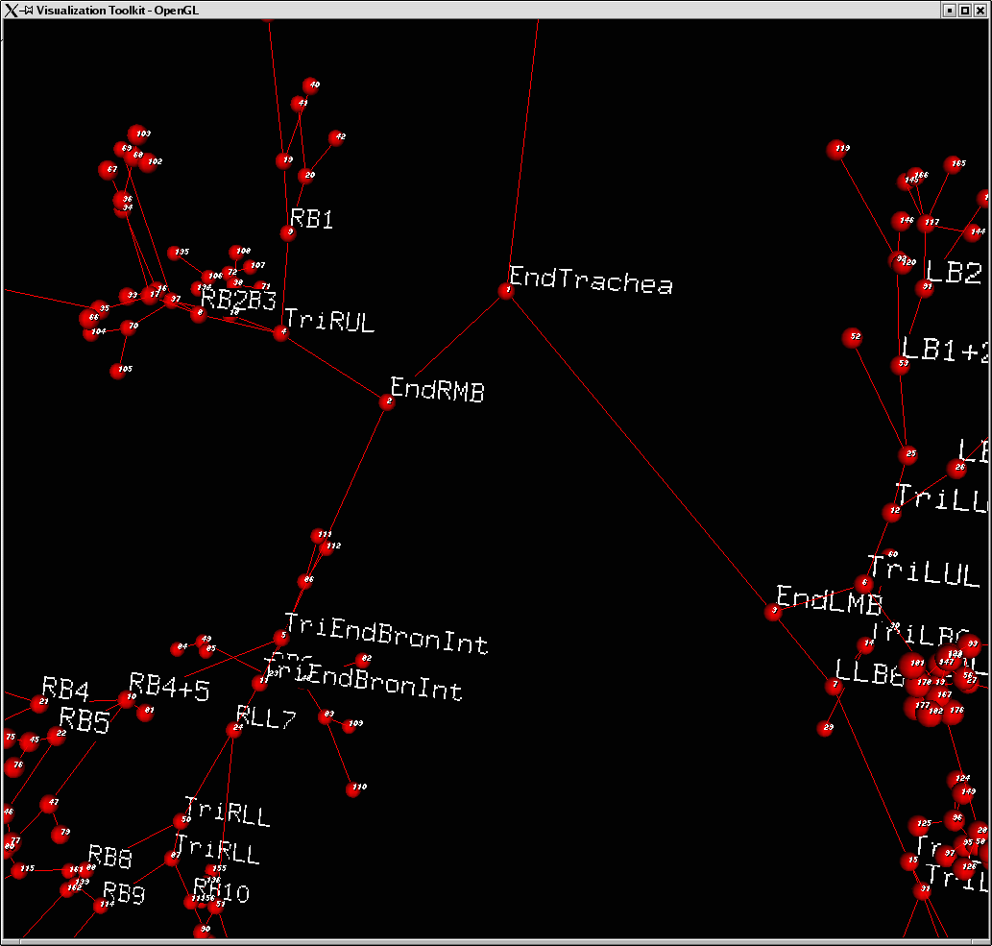

Fig. 14.: An anatomical atlas with individual anatomical names assigned to each branch-points (left), a labeled airway tree (right).

